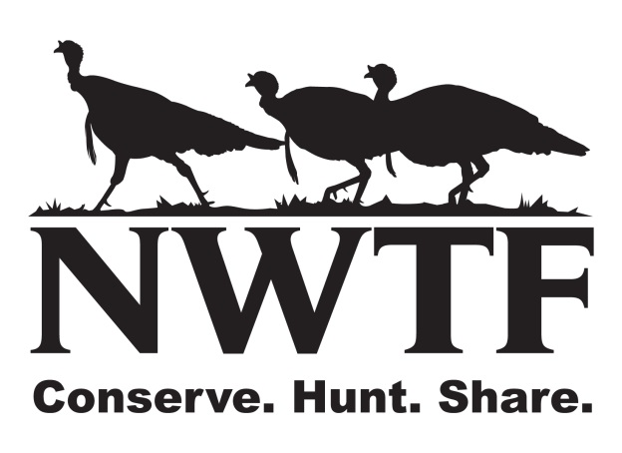

Save the Habitat. Save the Hunt.

Connecting Individuals to the Outdoors
Application

Individuals (age 18-45) applying for this program will need to complete the online hunter education and be committed to attend seminars and outdoor activities for 3-4 hours a month for 11 consecutive months.

Name:
Please print First Middle Last
Address:

_____________________________________________________________________
City State ZIP code:
Home Phone: (____)_________________ Cell Phone: (___)_____________________
E-mail:
Date of Birth: (Mo/Day/Yr)
Parent or Guardian: (if a minor)

Please print First Middle Last

Please sign here First Middle Last
Are you a veteran? _________________________________________________________________

Have you ever been convicted of a felony? ______________________________________________

Do you have a history of mental illness? Please explain. ___________________________________

Do you have a history of drug or alcohol abuse? Please explain. ____________________________

Emergency Contact Information:
Name:
Please print on this line First Middle Last
Relationship: ______________________ Phone Number: _____________________

In order to provide a quality hunting experience we ask that you please provide us with the following information. Please give as much detail as possible and feel free to attach another sheet if necessary.

Hunting Experience:
Have you ever hunted before yes or no? If yes when did you last hunt?

Have you ever participated in an NWTF outreach event yes or no? If yes when & where __________

Do you have your own shotgun Yes or No? ______________________________________________

Please briefly explain your level of hunting experience (species hunted, weapons used, etc)
________________________________________________________________________________________________________________________________________________________________________________________________________________________________________________
What has been your biggest obstacle that has prevented you from participating in shooting sports?
________________________________________________________________________________________________________________________________________________________________________________________________________________________________________________
What are your expectations of this program and what are you looking to learn or gain from this program? ________________________________________________________________________________________________________________________________________________________________________________________________________________________________________________

If you are mobility-challenged, please complete the following questions:

What is your disability? (If you have a spinal cord injury please indicate para or quad and level) _______________________________________________________________________________________________________________________________________________________________________________________________________________
- Do you have difficulty standing yes or no? If yes explain:

- Do you use crutches/walker or other equipment to get around please explain:

- Do you use a wheelchair yes or no? If yes can you get out of your chair?
- Can you transfer to another vehicle such as a Utility type (Polaris Ranger or Kubota)? Yes or No
  - If yes can you transfer on your own or will you need assistance
  - If no can you be transported while in your chair as it sits on a flat trailer being pulled by the above Utility vehicle? Yes or No (Note all safety precautions would be used in this type of transportation) Yes or No.
- Do you have use of both arms? Yes or No. If no and use of only one arm right or left
- Do you have use of both hands? Yes or No. If no and use of only one hand right or left
- Do you have vision difficulty? Yes or No. If yes please explain

Have you ever participated in any other handicapped hunt yes or no? If yes with whom, when & where: __________________________________________________________________________

If needed, do you have someone who would be available to accompany you during this program, yes or no? If yes list their relationship to you

How did you find out about this program? (circle one): Friend Invitation Newspaper Facebook

Notes:
- Inexperienced Hunters are encouraged and welcomed to participate in this program.
- Participant must complete the online hunter education prior to our second seminar in February, 2017.
- Registration Fee of $135.00 will pay for required licenses.
- Participants are responsible for all transportation to and from the program.
- Filling out this application does not guarantee you a spot in the program, as space is limited.
- Any special dietary needs must be met by the participant.

Direct all questions and return this completed form (last day to register is Feb 25) to
Dan Fitzgerald - National Wild Turkey Federation
515-864-8235
fitzgeralddar@hotmail.com

Thank you for your interest in this program.

