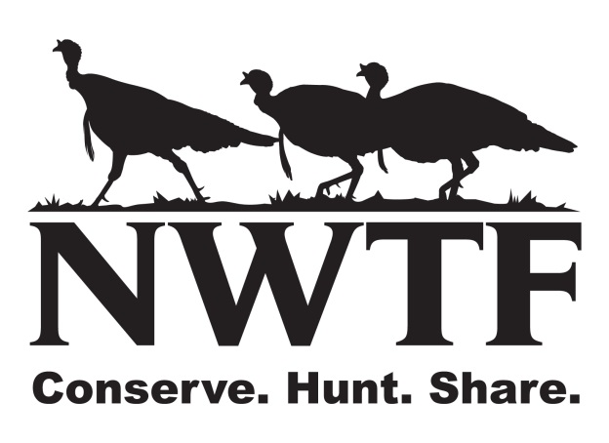

Save the Habitat. Save the Hunt.

Connecting Individuals to the Outdoors
Mentor Application

Individuals applying for this program to mentor a novice participant will need to be committed to attend seminars and outdoor activities for 3-4 hours a month for 11 consecutive months. Mentor applicants will have a background check conducted.

Name:
Please print First Middle Last
Address:

_____________________________________________________________________
City State ZIP code:
Home Phone: (____)_________________ Cell Phone: (___)_____________________
E-mail:
Date of Birth: (Mo/Day/Yr)
Are you a veteran? _________________________________________________________________

Have you ever been convicted of a felony? ______________________________________________

Do you have a history of mental illness? Please explain. ___________________________________

Do you have a history of drug or alcohol abuse? Please explain. ____________________________

Emergency Contact Information:
Name:
Please print on this line First Middle Last
Relationship: ______________________ Phone Number: __________________________
In order to provide a quality hunting experience we ask that you please provide us with the following information. Please give as much detail as possible and feel free to attach another sheet if necessary.

Hunting Experience:
How many years have you hunted for? ______ Have you mentored hunters before?

Have you ever participated in an NWTF outreach event yes or no? ___________________________

If yes when & where ________________________________________________________________

Are you able to commit to several hunting experiences throughout the year? ___________________
If not what hunts/months can you participate? ____________________________________________
Please briefly explain your level of hunting experience (species hunted, weapons used, etc)
________________________________________________________________________________________________________________________________________________________________
What/How do you expect to help participants as a mentor?
________________________________________________________________________________________________________________________________________________________________
What are your expectations of this program and what are you looking to learn or gain from this program? ________________________________________________________________________________________________________________________________________________________________Mentors will help their assigned novice hunter with any hunting-related questions or situations that may arise in the field during range days and the actual hunts. Mentors cannot hunt or handle/carry the firearm used by the participant, unless the firearm jams and the participant requires help getting it in working condition or for other safety reasons. Thank you for your interest in this program.

Direct all questions and return this completed form to
Dan Fitzgerald - National Wild Turkey Federation
515-864-8235
fitzgeralddar@hotmail.com

Mike Hagen - National Wild Turkey Federation (Iowa)
319-551-8265
mvhagen@prodigy.net

